Whether you’re involved in a Manager 360 as the subject or a rater, your contribution is key. For this reason, it’s important to have a solid understanding of study and processes involved. Please review the following information to ensure you’re well informed and prepared to maximize the impact of your organization’s Manager 360.

What is a Manager 360?
A Manager 360 is a development tool used to provide a manager with feedback from a 360-degree perspective. People that work closely with the manager rates them on key competencies and behaviors, and results are reported back in an individualized report. The purpose is to provide the manager with balanced feedback and a solid understanding of their strengths and areas of opportunity. Below are common rater groups solicited for feedback in a Manager 360:

- Self (manager rating themselves)
- Supervisor
- Direct Reports
- Peers

Benefits of Manager 360:
- Provides Balanced Feedback
- Encourages Dialogue
- Increases Accountability
- Provides an Opportunity for Professional Development
- Increases Self-Awareness

360 Model
Each manager will be rated on work behaviors that fall under key competencies. For example, “Accountability” is a common competency that is measured. The graphic below shows common behaviors that may fall under the competency “Accountability”. Please note that the 360 assessment you participate in, will likely have numerous competencies to rate.

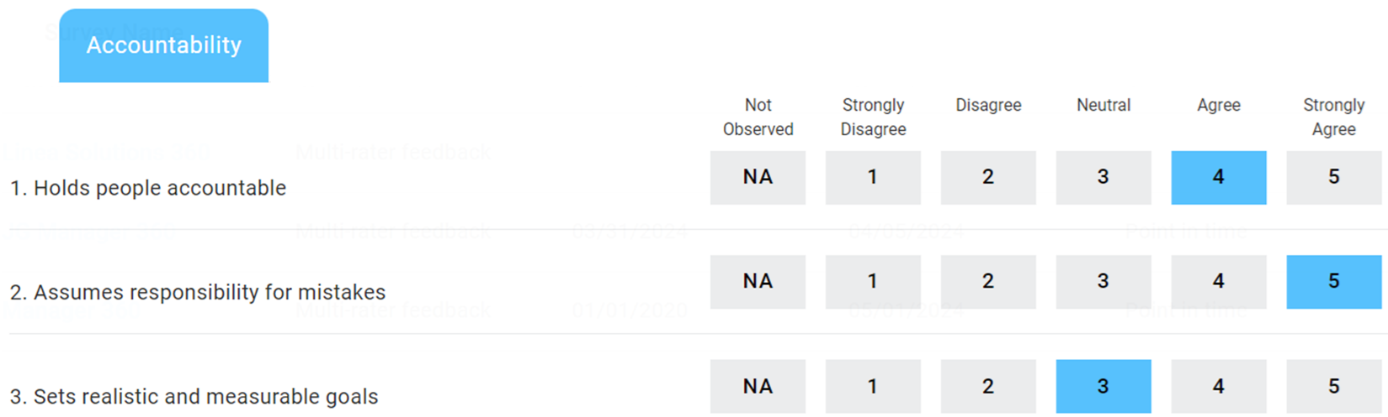

Tips for Raters
As a rater you’re either a manager rating themselves or someone who has a working relationship with this manager (Direct Report, Peer, Supervisor, etc.). For this reason, your feedback is invaluable to this manager’s professional development. Below are some things to consider when completing the Manager 360:
Rating Scale:
- Please review the rating scale closely before completing the assessment. Remember, the top rating is reserved for managers that are an absolute role model for the behavior being rated. The bottom rating is reserved for managers that need significant improvement for the behavior being rated.

Open-Ended Questions:
- The Manager 360 will likely have various open-ended questions to answer. When answering these questions, please be as specific as possible. The goal is to provide the manager with detailed, actionable feedback. See below for examples of comments that are helpful/not helpful.

- Question: What makes this person especially effective?
  - Not Helpful: “William is very supportive”.

  - Helpful: “William follows up with me on a regular basis and is always available to support me when needed. Also, I can always count on him to be encouraging”.

- Question: What could help this person be more effective?
  - Not Helpful: “I just wish William was a better manager.”

  - Helpful: “More 1-on-1 check ins would help William be more effective. This would provide the opportunity to provide more support/guidance and recognize employees when appropriate”.

Process & Protocols:
Individualized Report:
- Once data collection is finished, the manager will receive an individualized 360 report. This report will include data from each rater group at the competency and behavior level, verbatim comments, and recommendations.

Confidentiality:
- Data from rater groups such as Direct Reports and Peers are typically reported in aggregate to maintain confidentiality. Names are not associated with responses to ensure raters are comfortable providing candid feedback.
- Typically, only Self and Supervisor ratings are non-confidential.

Meeting with Supervisor:
- Managers are encouraged to meet with their supervisor once they have received their 360 individualized report. This gives the manager a chance to clarify feedback, discuss strengths/opportunities and begin working on a plan of action.

Taking Action:
- Managers are expected to create a plan of action based on their 360 results. Details and progress of this plan are typically reported to their immediate supervisor.

