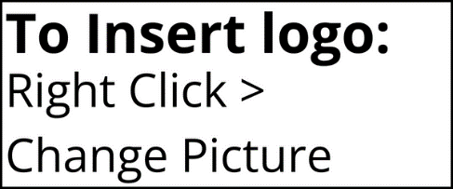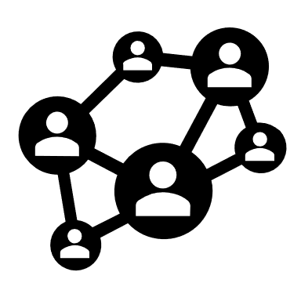

**DEVELOPING OUR ORGANIZATION**

**MAKING *[COMPANY NAME]* A BETTER PLACE TO WORK FOR YOUR FORMER COWORKERS**

**IDENTIFYING WHAT WE DO WELL AND WHAT CAN BE IMPROVED**

To ensure People Element can contact you, please make sure your contact information is up to date with Human Resources prior to leaving the organization. You will be able to participate in the survey via ***(enter method – email/text/phone call, etc.)****.*

If you have any questions or concerns about this process, please contact:

***(Company HR contact information)***

**PEOPLE ELEMENT NEEDS TO REACH YOU**

**YOUR FEEDBACK CAN ASSIST US IN:**

We care about your work experience with us and want to make ***(Company Name)*** an even better place to work. For this reason, we’re partnered with People Element, a third-party organization, to conduct exit interviews on our behalf. Your honest feedback during your exit interview will be valuable as we work to continuously improve our organization.

People Element was selected as a third-party partner to ensure all individual responses are kept confidential, so please provide your honest feedback.

**YOUR RESPONSES ARE CONFIDENTIAL**

**WE WANT YOUR FEEDBACK!**